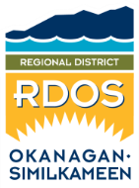 | Feedback Form  Regional District of Okanagan-Similkameen  101 Martin Street, Penticton, BC, V2A-5J9  Tel: 250-492-0237 / Email: planning@rdos.bc.ca

TO: Regional District of Okanagan-Similkameen FILE NO.: X2025.001-BLB

FROM: Name: _____________________________________________________
(please print)
Street Address: ______________________________________________________

RE: Business Licence Regulation Amendment Bylaw No. 3100.02

My comments / concerns are:
I do support the proposed amendments.
I do not support the proposed amendments.

Please provide any comments you wish the Board to consider:

Feedback Forms must be be submitted to the RDOS office prior to noon on the day of the applicable Board meeting.
All representations, including names, will be made public if and when they are included in the Board Agenda.

