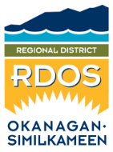 | Feedback Form  Regional District of Okanagan Similkameen  101 Martin Street, Penticton, BC, V2A-5J9  Tel: 250-492-0237 / Email: planning@rdos.bc.ca

TO: Regional District of Okanagan Similkameen FILE NO.: X2022.001-RGS

FROM: Name: _____________________________________________________
(please print)
Street Address: ______________________________________________________
Date: ______________________________________________________

RE: South Okanagan Sub-Regional Growth Strategy Review
Amendment Bylaw No. 2770.02, 2022

My comments / concerns are:
I do support the proposed amendment to the South Okanagan Sub-Regional Growth Strategy Bylaw.
I do not support the proposed amendment to the South Okanagan Sub-Regional Growth Strategy Bylaw.

Please provide any comments you wish the Board to consider.
Written submissions will be considered by the Regional District Board

Feedback Forms must be completed and returned to the Regional District
prior to noon on the day of the applicable Regional District Board meeting.

