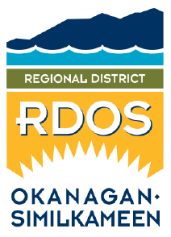**Feedback Form**

# Regional District of Okanagan-Similkameen

### 101 Martin Street, Penticton, BC, V2A-5J9

Tel: 250-492-0237 / Fax: 250-492-0063 / Email: [planning@rdos.bc.ca](mailto:planning@rdos.bc.ca)

**TO:** Regional District of Okanagan-Similkameen **FILE NO.:** E2025.005-TUP

**FROM:** Name:

(please print)

Street Address:

**RE: Temporary Use Permit (TUP) Renewal – “Vacation Rental” Use**

**6900 Indian Rock Road**

My comments / concerns are:

I do support the proposed use at 6900 Indian Rock Road.

I do not support the proposed use at 6900 Indian Rock Road.

Please provide any comments you wish the Board to consider:

Feedback Forms must be be submitted to the RDOS office by **August 14, 2025**.   
All representations, including names, will be made public if and when they are included in the Board Agenda.

Protecting your personal information is an obligation the Regional District of Okanagan-Similkameen takes seriously. Our practices have been designed to ensure compliance with the privacy provisions of the *Freedom of Information and Protection of Privacy Act* (British Columbia) (“FIPPA”). Any personal or proprietary information you provide to us is collected, used and disclosed in accordance with FIPPA. Should you have any questions about the collection, use or disclosure of this information please contact: Corporate Officer, RDOS, 101 Martin Street, Penticton, BC V2A 5J9, 250-492-0237.