

**TEMPORARY**

**USE PERMIT**

FILE NO.: C2022.006-TUP

|  |  |
| --- | --- |
| Owner: | Agent: |

### **GENERAL CONDITIONS**

1. This Temporary Use Permit is issued subject to compliance with all of the bylaws of the Regional District of Okanagan-Similkameen applicable thereto, except as specifically varied or supplemented by this Permit.
2. The land described shall be developed strictly in accordance with the terms and conditions of this Permit, and any plans and specifications attached to this Permit which shall form a part thereof.
3. Where there is a conflict between the text of the permit and permit drawings or figures, the drawings or figures shall govern the matter.
4. This Temporary Use Permit is not a Building Permit.

### **APPLICABILITY**

1. This Temporary Use Permit applies to, and only to, those lands, including any and all buildings, structures and other development thereon, within the Regional District as shown on Schedules ‘A’, ‘B’, ‘C’, and ‘D’ and described below:

### Legal Description: Lot C, District Lot 918S, SDYD, Plan 34109

Civic Address: 503 Wilson Mountain Road

Parcel Identifier (PID): 003-014-380 Folio: C-04225.220

**TEMPORARY USE**

1. In accordance with Section 20.0 of the Electoral Area “C” Official Community Plan Bylaw No. 2452, 2008, the land specified in Section 5 may be used for a “vacation rental” use as defined in the Electoral Area “C” Zoning Bylaw, being the use of a residential dwelling unit for the accommodation of paying guests occupying the dwelling unit for a period of less than 30 days.

### **CONDITIONS OF TEMPORARY USE**

1. The vacation rental use of the land is subject to the following conditions:
2. the vacation rental use shall occur only between May 1st and October 31st;
3. the following information must be posted within the dwelling unit while the vacation rental use is occurring:
   1. the location of property lines by way of a map;
   2. a copy of the Regional District’s Electoral Area “C” Noise Regulation and Prohibition Bylaw;
   3. measures to address water conservation;
   4. instructions on the use of appliances that could cause fires, and for evacuation of the building in the event of fire;
   5. instructions on the storage and management of garbage;
   6. instructions on septic system care; and
   7. instructions on the control of pets (if pets are permitted by the operator) in accordance with the Regional District’s Animal Control Bylaw.
4. the maximum number of bedrooms that may be occupied by paying guests shall be two (2);
5. the number of paying guests that may be accommodated at any time shall not exceed four (4);
6. a minimum of two (2) on-site vehicle parking spaces shall be provided for paying guests;
7. camping and the use of recreational vehicles, accessory buildings and accessory structures on the property for vacation rental occupancy are not permitted; and
8. current telephone contact information for a site manager or the property owner, updated from time to time as necessary, as well as a copy of this Temporary Use Permit shall be provided to the owner of each property situated within 100 metres of the land and to each occupant of such property if the occupier is not the owner.

**COVENANT REQUIREMENTS**

1. Not applicable.

**SECURITY REQUIREMENTS**

1. Not applicable.

**EXPIRY OF PERMIT**

1. This Permit shall expire on December 31, 2022.

Authorising resolution passed by Regional Board on _____ day of ___________, 2022.

___________________________________

B. Newell, Chief Administrative Officer

****Regional District of Okanagan-Similkameen

101 Martin St, Penticton, BC, V2A-5J9

Telephone: 250-492-0237 Email: [planning@rdos.bc.ca](mailto:planning@rdos.bc.ca)

Temporary Use Permit File No. C2022.006-TUP

Schedule ‘A’

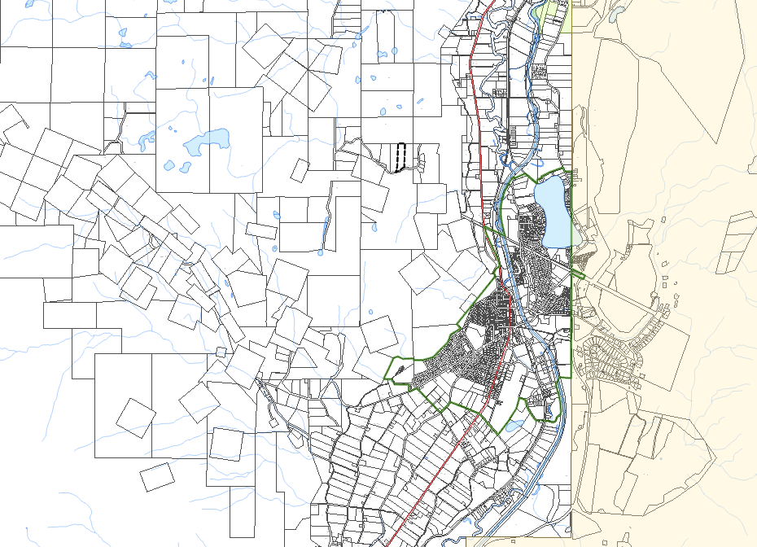



**OLIVER**

Subject Property

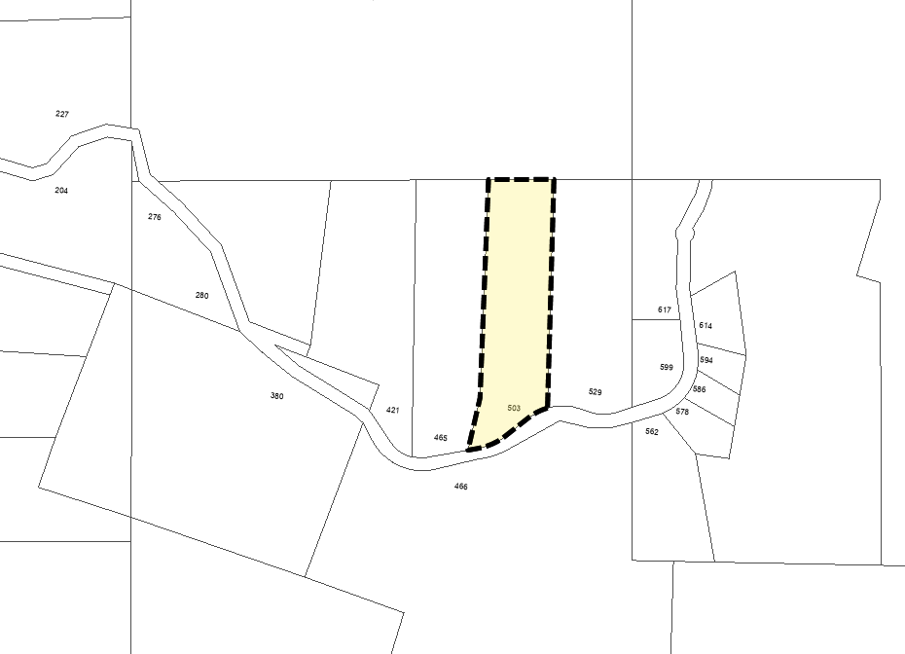

**WILSON MTN RD**

****Regional District of Okanagan-Similkameen

101 Martin St, Penticton, BC, V2A-5J9

Telephone: 250-492-0237 Email: [planning@rdos.bc.ca](mailto:planning@rdos.bc.ca)

Temporary Use Permit File No. C2022.006-TUP

Schedule ‘B’

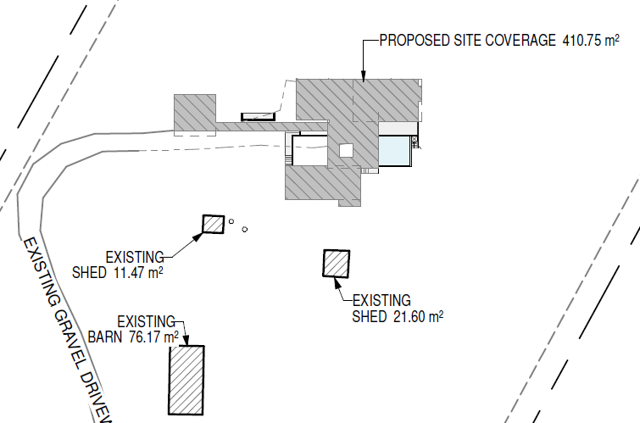

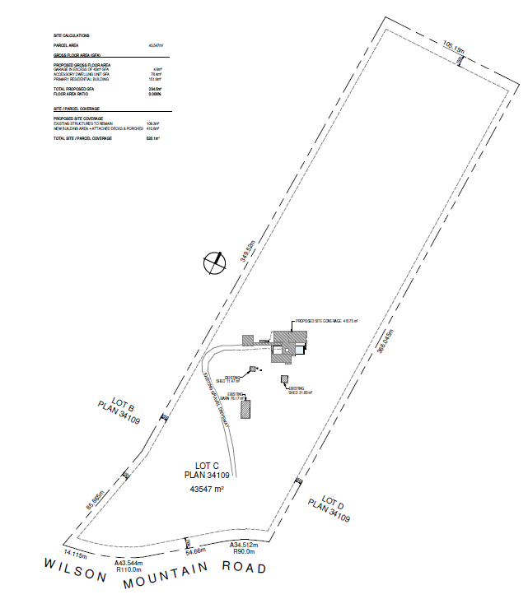

Subject Accessory Dwelling

****Regional District of Okanagan-Similkameen

101 Martin St, Penticton, BC, V2A-5J9

Telephone: 250-492-0237 Email: [planning@rdos.bc.ca](mailto:planning@rdos.bc.ca)

Temporary Use Permit File No. C2022.006-TUP

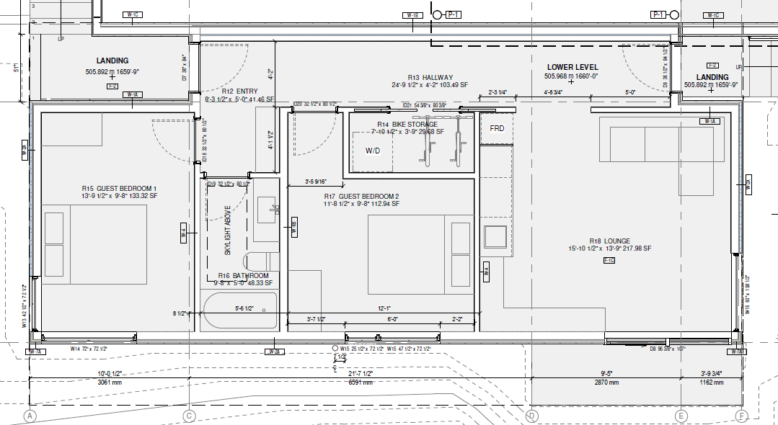Schedule ‘C’

Vacation Rental Use

****Regional District of Okanagan-Similkameen

101 Martin St, Penticton, BC, V2A-5J9

Telephone: 250-492-0237 Email: [planning@rdos.bc.ca](mailto:planning@rdos.bc.ca)

Temporary Use Permit File No. C2022.006-TUP

Schedule ‘D’

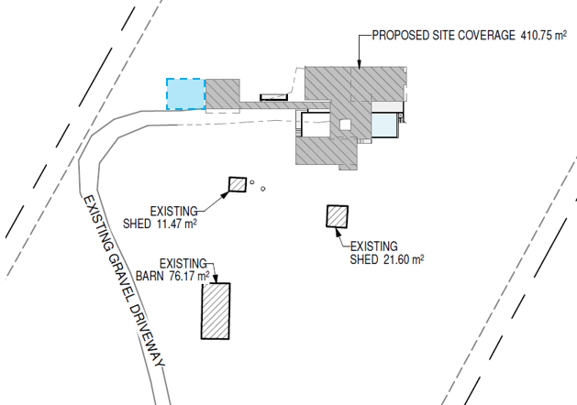

Approximate Parking Location